# 23056_Green Warriors_Innovation Report

ADVANCE DRIVER DROWSINESS DETECTION SYSTEM

## Author’s Name: Ayush Gupta Co-Author’s Name: Abdus Samad Suhail

1. **ABSTRACT**

Truck drivers who transport cargo and heavy materials over long distances during the day and night time, often suffer from a lack of sleep. fatigue and drowsiness are some of the leading causes of major accidents on highways. Exhausted drivers who doze off at the wheel are responsible for about 40% of road accidents, says a study by the Central Road Research Institute (CRRI) on the 300-km Agra-Lucknow Expressway. According to the latest data released by road transport and highways minister Nitin Gadkari, 1,47,913 people were killed in road accidents in 2022, with Uttar Pradesh reporting the maximum number of 20,124 road accident fatalities, followed by Tamil Nadu with 16,157 deaths. The finding rings the alarm bell on how Indian highway motorists ignore the importance of taking adequate rest and end up endangering lives. In a country where road accidents claim lives every 3 minutes it has become necessary to come up with a solution. A driver drowsiness detection system is our answer to the above problem. This system detects if our driver is sleepy or drowsy and alerts the driver so that an accident can be prevented.

## INTRODUCTION

In this project, we are going to build a **Sleep Sensing and Alerting System for Drivers using Raspberry Pi, OpenCV, and Pi camera module**. The basic purpose of this system is to track the driver’s facial condition and eye movements and if the driver is feeling drowsy, then the system will trigger a warning message. Now, this system can be implemented on any computer. But definitely, no one is going to put a whole computer inside a car, thus I have also implemented this system in a Raspberry Pi , so that the whole system can be easily fitted in front of the driver in the car. Also, all the algorithms have been used in this system are very much optimized, thus this system will work in real-time, which is very much necessary for this application

## REVIEW OF EXISTING RESEARCH (IF ANY)

The existing methods of drowsiness detection are either sensor or vision-based.

Jyotsnna Gabhane et al. In [1] uses IR sensor and Arduino to check the frequency of eye blinking to check if the driver is drowsy or not.

Rajeshwari Rawal et al. In [2] one is based on physiology, which checks heart rate and brain activity by ECG (Electrocardiogram), EOG(Electrooculogram) , EEG, and EMG(Electromyogram).

## INNOVATION CONCEPT AND TECHNICAL FEATURES

Incorporating customized goggles technology amplifies the functionality of the drowsiness detection system, elevating the user experience to new heights. As part of the enhanced system, users can opt for personalized virtual goggles styles or themes, allowing for a tailored and visually appealing interface. These virtual goggles serve as dynamic indicators, seamlessly adapting to the user's facial features and expressions. For instance, when drowsiness is detected, the system can overlay virtual goggles with a design that signifies alertness, creating an engaging and intuitive visual cue. Moreover, the integration of augmented reality (AR) goggles enhances the immersive aspect of the system. AR overlays within the goggles can display real-time alerts or messages directly in the user's field of vision, ensuring immediate awareness. Users can also customize the appearance of these AR elements, offering a personalized touch to their safety interface. This amalgamation of advanced facial landmark detection, customizable virtual goggles, and augmented reality elevates the system's sophistication, making it not only effective in preventing drowsiness-related accidents but also a technologically innovative solution.

### ALGORITHM

* + The predictor **shape_predictor_68_face_landmarks.dat** finds landmarks on the face.

***effi.saenis.org Drive the Future*** Page **1** of **5**

* STEP 1: Start
* STEP 2: Start capturing video to detect face
* STEP 3: Pass the face in the predictor giving landmarks
* STEP 4: Using landmarks calculate EAR and distance between lips.
* STEP 5: If lip distance is greater than the threshold alarm is buzzed to alert the user
* STEP 6: If eye distance is less than a threshold then too the alarm is buzzed
* STEP 7: Stop

### METHODOLGY

* **PI CAMERA MODULE:**

Pi camera module board is high high-definition 5MP camera that can capture good quality pictures and videos. It is compact and lightweight. It captures the video which is fed to Raspberry Pi which further processes it.

### RASPBERRY PI zero:

Raspberry Pi Zero is integrated with a 64-bit quad-core cortex- A72 ARM v8, Broadcom BCM2711, and runs at a speed of 1.5GHz. Form Factor: Nano-ITX. Raspberry Pi equipped with Bluetooth 5.0, BLE, and gigabit ethernet and has 802.11ac wireless at 2.4GHz and 5GHz. It provides faster data transfer with two USB 3.0 ports, two USB 2.0 ports, micro-SD slot for data storage and loading operating systems. The Raspberry Pi 4 has 2 microHDMI ports (supports 4k@60p), 2 lane MIPI DSI display port, 2 lane MIPI CSI camera port and 4-pole stereo audio and composite video port. In our vehicle it is a part of the driver drowsiness detection system as well as it powers the dashboard.

### BUZZERS:

A piezo buzzer is also used in this system. It is basically is a tiny speaker which connects with PI and can be set to make any tone at any frequency. It is used to alert the driver incase he/she is asleep.

**POWER SUPPLY:** A power bank of 7000Mah is used.

## CALCULATION AND ANALYSIS

The working system analysis is as follows:

* The user logs into its account and starts the system.
* The camera starts capturing the video and using the **haarcascade_frontalface_default.xml** the detection of the face is done.
* Detecting if the driver is drowsy is as follows:

### DETECTING IF THE EYE IS OPEN OR CLOSED:

Using the value provided by the predictor the EAR is calculated.

EAR = (|(P2-P6)| + |(P3-P5)|) / (2* |(P1 - P4)|)

If the value of the EAR at a particular time is less than the threshold value for a given amount of time. The alarm is buzzed and driver is alerted.

### DETECTING THE YAWN:

To detect a yawn distance between upper lip and lower lip is calculated using the landmarks. We will use the DLIB's facial landmark model here. Then we will simply calculate the distance between the midpoint of the upper lip to the midpoint of the lower lip and so as to differentiate between talking and yawning. When the distance is greater than given threshold the alarm buzzes.

## MASS PRODUCTION FEASIBILITY

Mass production feasibility of the proposed system initially depends on the market requirements, that is:

* The system is compatible with most vehicles.
* The system can accurately map all the points on the face
* The system functions well in low light.
* The system is autonomous, requiring no user input to function.
* The system is able to detect sleepiness through spectacles
* The system is able to detect any skin-colored person

The system fulfills the market requirements to be produced on a mass or large scale.

The production of the system on a large scale would require various types of resources. The procurement of market manufactured items like microcontroller boards etc. would be required. Machinery and tools related to circuit design and electronics manufacturing are prerequisites.

For optimization, different analytical software can also be used to provide a cost effective, feasible, accurate and quality product to be implemented in the industry of automobiles.

## Cost calculations

The procurement cost of the different components of the proposed system are:

* Raspberry pi zero - Rs 1000/- per piece
* Pi Camera module - Rs 400/- per piece
* Piezo Buzzer - Rs 50/- per piece Total procurement cost - Rs 1500/-

Apart from these procurement costs, additional manufacturing costs and other expenses would also have to be considered while producing the system on a mass level

Hence the total cost of the system will be - Rs 2500/-

## Result and conclusion

So, in this way, we have built this drowsiness and yawn detection system. Now there are several improvements one can add to this project. The face detection part can be improved by using some other algorithms, but in that case, one must have to use some optimized technique so that it will work in real-time in systems like Raspberry Pi. Further the hardware and software both can be improved in order to detect person in low light and detect person of any skin color. Also, the distance between person and hardware should not be problem for proper detection.

## SCOPE AND APPLICATIONS

The proposed system opens a wide window of applications:

1. This system helps in ensuring the safety of the drivers and other people on the road, thus preventing road accidents.
2. This system is beneficial for the truck drivers a lot as they get little rest transporting the cargo. It helps keeping them awake.
3. The taxi and cab drivers can use this system as well as it is pretty simple plug-in device for their cars.

## Limitations and future scope

This system has the following limitations:

* It malfunctions in low level of light as it is not able to properly detect the face of the person
* It is not able to detect the face of a dark skin colored person without proper lighting.
* The distance between the hardware and the driver should be fixed for proper detection

This system is available in certain expensive vehicles at the moment, and our device being cheaper will make availability of this system to each and every automobile. The above-mentioned limitations can be minimized by using a better hardware and some other algorithms, but in that case, one must have to use some optimized technique so that it will work in real-time in systems like Raspberry Pi.

## References

1. Jyotsna Gabhane, Dhanashri Dixit, Pranali Mankar, Ruchika Kamble, Sayantani Gupta “Drowsiness Detection and Alert System: A Review”
2. Miss. Rajeshwari Sanjay Rawal,

Mr.Sameer.S.Nagtilak

“Drowsiness Detection Using RASPBERRY-PI Model Based On Image

Processing”.

1. Y.Mrudula, A.Deepthi, Ch.Ganapathi Reddy

“Drowsiness Detection in Real Time Driving Conditions”

1. [Sparklers_The_Makers](https://www.instructables.com/member/Sparklers_The_Makers/)

“Realtime Drowsiness and Yawn Detector Using Raspberry Pi or Any Other PC”

1. Dr.S.Priyadarsini, ChahakAgarwal.D,

Deshiya Narayan.M

“Driver Drowsiness Detection System Using Raspberry Pi”

# APPENDIX-1 : DESIGN VIEWS AND

**PHOTOGRAPHS**

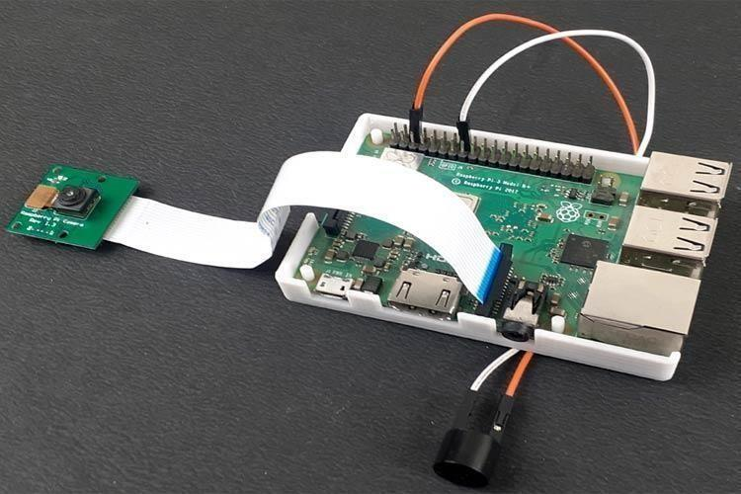

Circuit of the Driver Drowsiness System

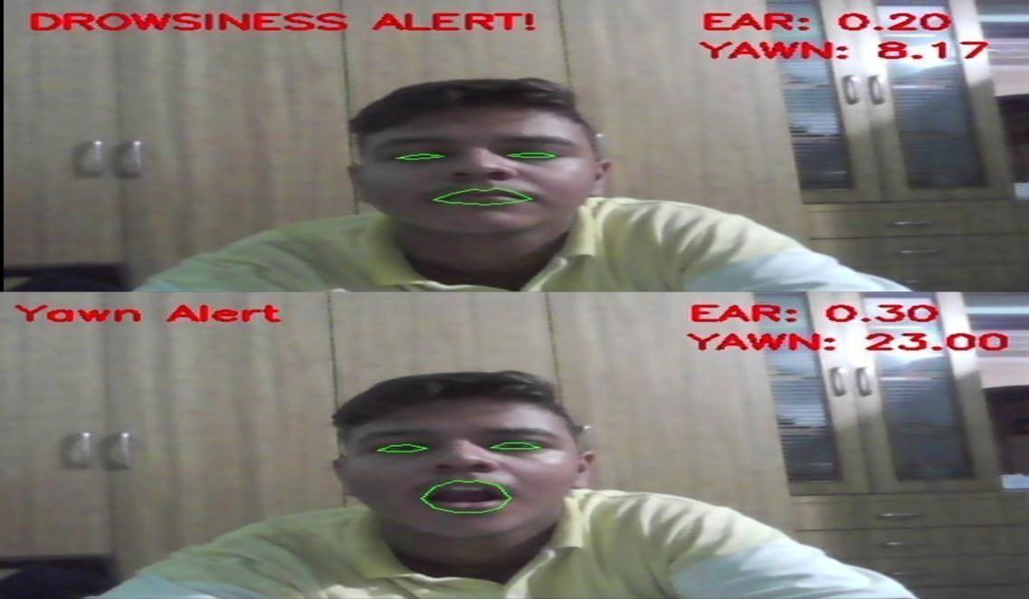

Testing of the system

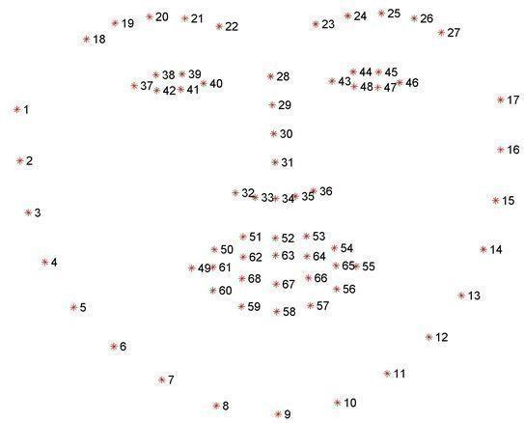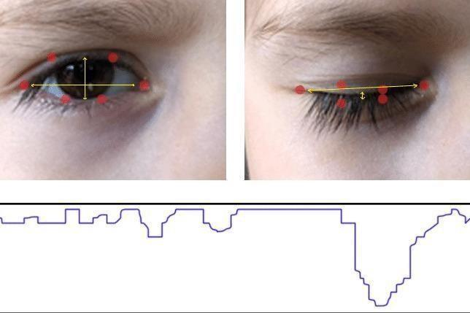

Face points Open eye and closed eye detection

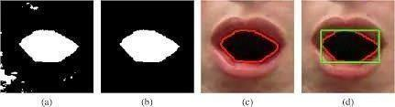

Detection of yawn